AMAZON SALES ANALYSIS
Business Requirements

1. Charts Requirement
- YTD Sales by Month (Line Chart): Visualize sales trends over time on a monthly basis to identify seasonal patterns and growth trends.
- YTD Sales by Week (Column Chart): Display sales data on a weekly basis to pinpoint shorter-term fluctuations and performance insights.
- Sales by Product Category (Text/Heat Map): Utilize a text or heat map visualization to provide a high-level overview of sales across different product categories.
- Top 5 Products by YTD Sales (Bar Chart): Highlight the top-performing products based on year-to-date sales to focus on key revenue generators.
- Top 5 Products by YTD Reviews (Bar Chart): Identify the top-rated products by year-to-date reviews to understand customer preferences.

2. KPI's Requirement
- YTD Sales: Monitor year-to-date sales to gauge the overall revenue performance over time.
- QTD Sales: Track quarterly sales figures to identify sales trends and fluctuations.
- YTD Products Sold: Analyse the total number of products sold throughout the year to understand product movement.
- YTD Reviews: Keep tabs on year-to-date product reviews to assess customer feedback and satisfaction.

3. Source Business Requirement Screenshots
The following screenshots are included for reference. The requirements above have been converted into editable Word text.
Charts Requirement – Source Screenshot
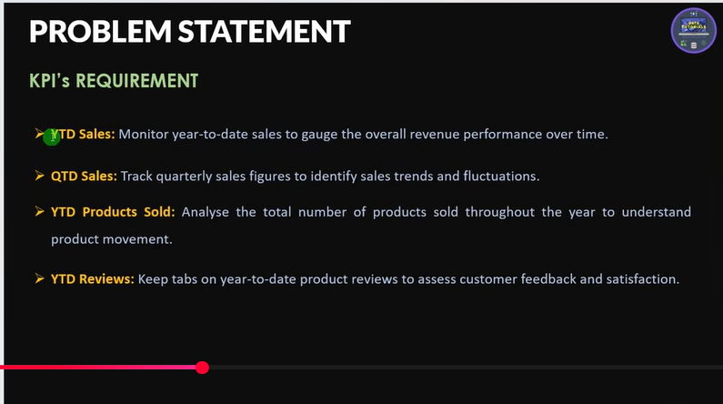
KPI's Requirement – Source Screenshot
